SQL Lab
David Jayakumar
G00419108
Group A
15-02-24

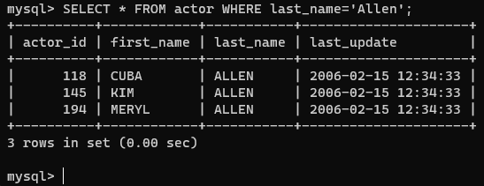
1)
2) 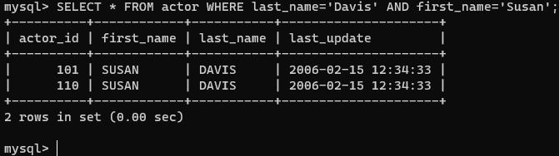
3)
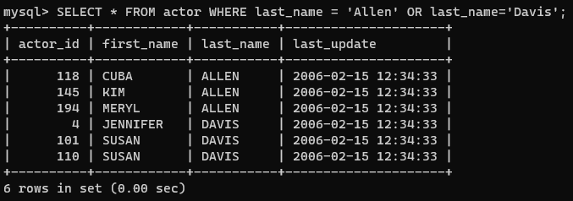

4)
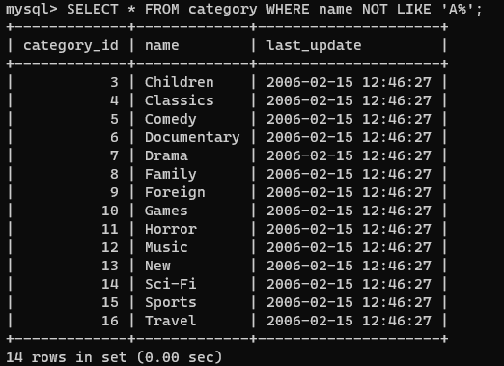
5) 
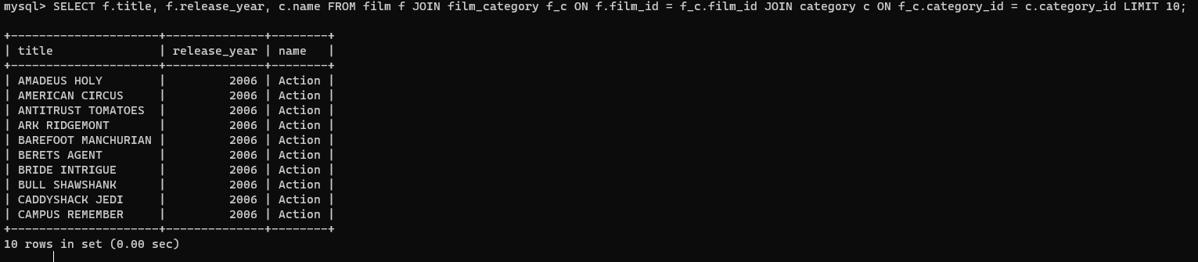
6)

7)
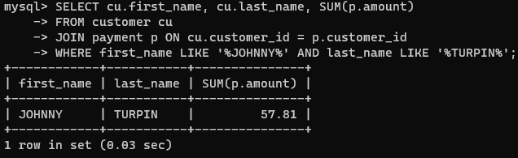
8)
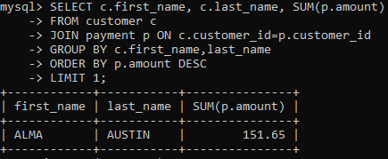
9) 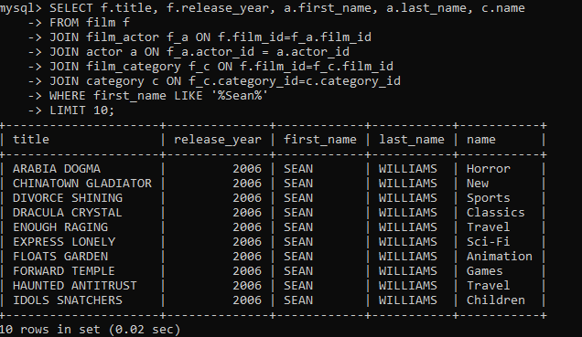
10)
i. return all the movies available in English and French
ii. return all customers email address that start with the letter a
iii. return the phone numbers of customers who’s name starts with the letter d
iv. return the all email addresses of the managers in staff
v. list the top 5 actors who have the most films
vi. return a list of movies that weren’t returned when rented.
vii. return the name of the people who didn’t return a rented movie
viii. return a list of the movies that were rented the most
ix. list the top 3 customers who bought rentals
x. find which month has the highest number of rentals

